Aseptic Technique

Results and Observations

Insert photographs of tubes here:
Kocuria rhizophilia in broth

Kocuria rhizophilia on slant

Escherichia coli in broth
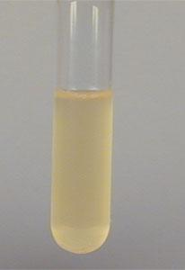

Escherichia coli on slant

Complete the table:
Bacterial Species and media | Description of growth (amount, color, etc.)
Kocuria rhizophilia in broth | Bacterial growth produced uniform yellow pigment , Amount= +++
Kocuria rhizophilia on slant | Yellow numerous cloudy colonies observed, Amount= +++
Escherichia coli in broth | Uniform cream turbidity observed, Amount= +
Escherichia coli on slant | Creamy, moist and glistering colonies were observed, Amount= ++

Were you successful at your aseptic transfers? Yes

